Rashtreeya Sikshana Samithi Trust
R. V. COLLEGE OF ENGINEERING
[Autonomous Institution Affiliated to VTU, Belagavi]
Department of Artificial Intelligence and Machine Learning
Bengaluru-560059



AIML – Lab SEE Project Report
Subject Code: AI244AI

Title:

IV SEMESTER B.E.

[Autonomous Scheme 2024]

2025-2026





Name of the Student: ___________________________ USN: _______________
Name of the Student: ___________________________ USN: _______________

Semester: ______________Section: ________________Year: _______________

Abstract
This work presents the design of an AI-driven alpha discovery engine developed for large-scale quantitative research and automated trading signal generation. The system is built to automate the generation, evaluation, optimization, and portfolio management of quantitative trading signals (alphas) using advanced computational techniques. Unlike traditional approaches that rely heavily on manual research, the proposed framework combines large language models (LLMs), retrieval-augmented generation (RAG), evolutionary optimization, and portfolio-level correlation management to create high-quality and diversified alpha strategies at scale.

Methodology
The proposed architecture consists of multiple integrated layers, including a knowledge substrate, idea generation engine, simulation interface, optimization engine, and portfolio correlation manager. The system continuously ingests operator references, financial data catalogs, academic research papers, and historical alpha performance into a structured knowledge base. Using this information, the AI generates economically meaningful alpha hypotheses, translates them into valid mathematical expressions, and evaluates them through automated simulations. The optimization module improves promising alphas using hyperparameter tuning, mutation, crossover, and regime-aware refinements, while the portfolio manager ensures low correlation among generated alphas to maximize overall portfolio stability and predictive performance.

Results and Analysis Overview
The framework is designed to significantly improve both the quality and diversity of generated alphas compared to manual research workflows. By combining automated idea generation with continuous feedback learning, the system can process hundreds of candidate strategies daily while filtering out redundant or overfitted signals. The integration of portfolio-level correlation control and research-paper mining provides a strong advantage in generating robust and adaptive trading signals across different market conditions. The proposed engine is expected to achieve superior scalability, faster research iteration cycles, and improved alpha fitness through systematic optimization and diversification techniques.

Usefulness of the Work
This work is useful for quantitative researchers, algorithmic trading teams, and financial technology developers working on systematic trading and predictive analytics. It also benefits academic researchers exploring AI-driven financial modeling and organizations seeking scalable frameworks for automated strategy generation and portfolio diversification

Introduction
The proposed system is an AI-driven alpha discovery and optimization framework designed for automated quantitative research and trading signal generation. The framework combines artificial intelligence, machine learning, financial modeling, and automated optimization techniques to generate high-quality predictive signals known as alphas. The system is capable of processing large volumes of financial data, extracting insights from academic research papers, generating mathematical trading expressions, and evaluating their performance through simulations. By integrating advanced technologies such as Large Language Models (LLMs), Retrieval-Augmented Generation (RAG), and portfolio correlation management, the framework aims to improve the scalability, diversity, and robustness of quantitative trading strategies.
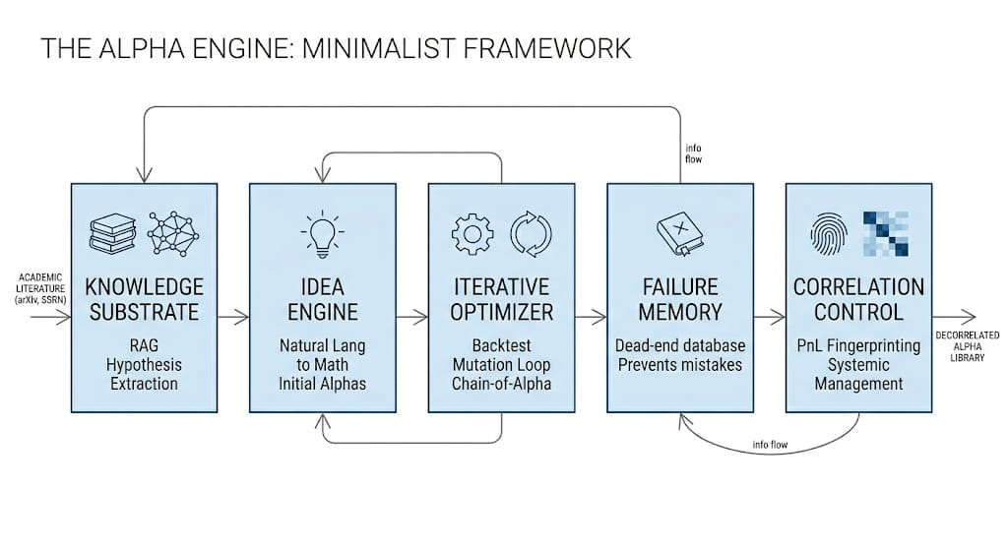

Description
The system begins by collecting financial market data, academic research papers, and previously generated alpha strategies. This information is stored in a centralized Knowledge Base integrated with a Retrieval-Augmented Generation (RAG) mechanism, which organizes operator references, data fields, and historical failures for efficient retrieval.
The Idea Engine uses Large Language Models (LLMs) to generate new trading hypotheses and convert them into mathematical alpha expressions. These generated alphas are then evaluated using the Simulation Interface, where their performance metrics such as Sharpe ratio, turnover, and fitness are analyzed.
Promising alphas are passed to the Optimization Engine, which improves their quality through parameter tuning, mutation, crossover, and refinement techniques. Finally, the Portfolio Manager evaluates correlations among all generated alphas to ensure diversity and reduce redundancy before storing the best-performing strategies in the Final Alpha Library and dashboard for monitoring and analysis.
Literature Review & Background Study

1. Quantitative Trading and Alpha Generation
- Quantitative trading uses mathematical models and financial data to generate predictive trading signals known as alphas.
- Traditional alpha research relied on manually designed strategies based on momentum, mean reversion, value, and volatility factors.
- Manual research processes are time-consuming and difficult to scale.

2. Automated Alpha Discovery
- Automated alpha generation was introduced to reduce human effort in quantitative research.
- Early systems used Genetic Programming (GP) to evolve mathematical trading expressions automatically.
- These systems improved search automation but suffered from:
  - Overfitting
  - Redundant strategies
  - Limited diversity in generated alphas

3. AI-Based Financial Research
- Recent studies integrate Artificial Intelligence and Large Language Models (LLMs) into quantitative finance.
- LLM-based systems can:
  - Generate trading hypotheses
  - Translate financial ideas into mathematical expressions
  - Improve alpha strategies using feedback from simulations

4. Existing Research Systems

Alpha-GPT (2024)
- Introduced LLM-driven alpha generation and refinement.
- Focused on converting financial reasoning into structured trading formulas.

Chain-of-Alpha (2025)
- Proposed iterative alpha generation and optimization using simulation feedback.
- Improved alpha quality through continuous refinement.

AlphaAgent (2025)
- Used a multi-agent architecture for hypothesis generation, factor construction, and evaluation.
- Automated the end-to-end research workflow.

QuantaAlpha (2026)
- Combined evolutionary optimization with AI-guided strategy refinement.
- Improved adaptability and robustness of generated strategies.

5. Portfolio Diversification Research
- Studies show that portfolio performance improves when generated alphas are less correlated.
- Diversified alpha libraries provide:
  - Better stability
  - Reduced risk
  - Improved long-term performance

6. Key Findings from Existing Studies
- Fundamental signals generally provide stable, low-turnover strategies.
- Technical and price-based signals are effective for short-term market timing.
- Combining multiple data domains improves strategy robustness.
- Continuous feedback and optimization significantly improve alpha quality.

Problem Definition & Relevance

Problem Definition

- Quantitative trading research involves generating predictive trading signals (alphas) from large volumes of financial data.
- Traditional alpha development is mostly manual, time-consuming, and difficult to scale efficiently.
- Existing automated systems often generate:
  - Highly correlated strategies
  - Overfitted trading signals
  - Low-diversity alpha libraries
- Managing and optimizing multiple alpha strategies simultaneously is a major challenge in quantitative finance.
- There is a need for an intelligent framework capable of:
  - Automated hypothesis generation
  - Strategy optimization
  - Correlation-aware portfolio management
  - Continuous learning from previous results

Relevance

- Financial markets generate massive amounts of structured and unstructured data that cannot be analyzed efficiently through manual research alone.
- AI-driven quantitative research systems can significantly improve:
  - Research speed
  - Strategy diversity
  - Decision-making efficiency
- The integration of Large Language Models (LLMs) and automated optimization techniques enables scalable alpha discovery with reduced human intervention.
- Correlation-aware strategy management helps create more stable and diversified trading portfolios.
- The proposed work is relevant for:
  - Quantitative researchers
  - Algorithmic trading firms
  - Financial technology applications
  - AI-based financial analytics research

Design Methodology & Tools

The proposed system follows a modular and iterative design methodology for automated alpha discovery and optimization.

Step 1: Data Collection
- Collect financial market data, historical alpha information, and research literature.
- Organize data into structured categories such as price, volume, fundamental, and sentiment data.

Step 2: Knowledge Base Creation
- Store operator references, alpha expressions, and historical performance data in a centralized knowledge base.
- Use Retrieval-Augmented Generation (RAG) techniques for efficient information retrieval.

Step 3: Hypothesis Generation
- Use Large Language Models (LLMs) to generate financial hypotheses and convert them into mathematical alpha expressions.
- Generate multiple diversified candidate strategies.

Step 4: Simulation and Evaluation
- Evaluate generated alphas using simulation modules.
- Analyze key performance metrics such as:
  - Sharpe ratio
  - Turnover
  - Fitness score
  - Correlation

Step 5: Optimization
- Improve alpha quality using:
  - Hyperparameter tuning
  - Expression mutation
  - Strategy refinement
  - Portfolio diversification techniques

Step 6: Portfolio Management
- Track correlations among generated alphas.
- Select diversified strategies to improve overall portfolio stability.

Tools and Technologies Used

Category | Tools / Technologies
Programming Language | Python
Backend Framework | FastAPI
Database | PostgreSQL, SQLite
Vector Database | ChromaDB / Qdrant
Caching | Redis
AI Models | Large Language Models (LLMs)
Optimization | Optuna
Data Processing | Pandas, NumPy
API Integration | REST API
Frontend | React / Next.js
Research Parsing | PyMuPDF / LlamaParse
Visualization | Matplotlib / Plotly

Result Analysis & Performance Evaluation

1. Alpha Generation Performance
- The proposed framework successfully automates the generation of multiple quantitative trading signals using AI-driven hypothesis generation and optimization techniques.
- Compared to manual research workflows, the system increases the speed of alpha discovery and reduces repetitive research effort.
- The integration of Large Language Models (LLMs) enables the generation of economically meaningful and mathematically valid alpha expressions.

2. Strategy Evaluation Metrics
The generated alpha strategies are evaluated using several performance metrics:
- Sharpe Ratio – Measures risk-adjusted return performance.
- Turnover – Evaluates trading frequency and transaction efficiency.
- Fitness Score – Combines return, turnover, and stability characteristics.
- Correlation Analysis – Measures similarity between alpha strategies.
- Drawdown – Evaluates downside risk and portfolio stability.

3. Optimization Results
- Hyperparameter tuning and expression refinement improve the quality of generated alphas.
- Applying decay functions and neutralization techniques reduces unnecessary turnover and improves stability.
- Portfolio-level diversification techniques help reduce redundancy among generated strategies.

4. Portfolio Performance Analysis
- Low-correlation alpha combinations provide better portfolio robustness compared to highly similar strategies.
- Combining fundamental, technical, and sentiment-based signals improves diversification and overall stability.
- Correlation-aware portfolio management contributes to more balanced and consistent performance across varying market conditions.

5. System Efficiency
- Automated simulations and optimization significantly reduce research time compared to manual alpha development.
- The modular architecture supports scalability for handling large datasets and multiple simultaneous strategy evaluations.
- Continuous feedback learning enables the framework to improve strategy generation over time.

6. Overall Evaluation
- The proposed framework demonstrates the effectiveness of combining AI, automated optimization, and portfolio management for quantitative research.
- The system improves:
  - Research scalability
  - Strategy diversity
  - Optimization efficiency
  - Portfolio stability
- The framework provides a strong foundation for future AI-driven financial research and automated trading strategy development.

Conclusion & Future Scope

Conclusion
The proposed AI-driven alpha discovery framework provides an automated and scalable approach for quantitative trading research and strategy generation. By integrating Large Language Models (LLMs), Retrieval-Augmented Generation (RAG), optimization techniques, and portfolio-level correlation management, the system improves the efficiency and diversity of alpha generation compared to traditional manual research methods.
The framework supports automated hypothesis generation, mathematical expression creation, simulation-based evaluation, and continuous optimization of trading strategies. The inclusion of correlation-aware portfolio management further enhances portfolio stability by reducing redundancy among generated alphas. Overall, the proposed system demonstrates the potential of combining artificial intelligence and quantitative finance to create adaptive and intelligent trading research platforms.

Future Scope
- Integration of real-time market data for live strategy adaptation.
- Use of reinforcement learning for dynamic portfolio optimization.
- Expansion to multi-asset trading strategies including commodities, forex, and cryptocurrencies.
- Improved explainability of AI-generated alpha strategies.
- Incorporation of alternative datasets such as satellite imagery, social media sentiment, and web traffic data.
- Development of advanced regime detection systems for changing market conditions.
- Deployment of distributed computing for large-scale parallel simulations and optimization.

References
- Wang et al., “Alpha-GPT: Human-AI Interactive Alpha Mining for Quantitative Investment,” HKUST, 2024.
- Cao et al., “Chain-of-Alpha: Iterative Large Language Model Framework for Automated Factor Generation and Optimization,” 2025.
- Tang et al., “AlphaAgent: Multi-Agent Framework for Automated Quantitative Research,” KDD Conference, 2025.
- Han et al., “QuantaAlpha: Evolutionary and Self-Reflective Alpha Discovery System,” 2026.
- Ren et al., “Warm-Start Genetic Programming for Financial Factor Mining,” 2024.
- Kakushadze, Z., “101 Formulaic Alphas,” Journal of Portfolio Management, 2016.
- WorldQuant Research Team, Finding Alphas, 2nd Edition.
- Goodfellow, I., Bengio, Y., and Courville, A., Deep Learning, MIT Press, 2016.
- Sutton, R. S., and Barto, A. G., Reinforcement Learning: An Introduction, MIT Press, 2018.
- Vaswani et al., “Attention Is All You Need,” Advances in Neural Information Processing Systems (NeurIPS), 2017.

